**Results:**

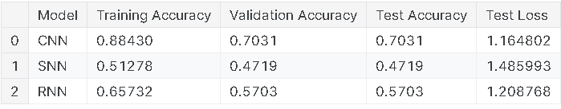

Figure Models comparison

Figure 1 summarizes the performance of three machine learning models (CNN, SNN, and RNN) on a particular dataset. Each model was trained, validated, and tested on the same data, and the results are presented in terms of training accuracy, validation accuracy, test accuracy, and test loss. The CNN model achieved the highest training accuracy but exhibited signs of overfitting, as evidenced by the gap between its training and testing accuracies. The SNN model performed the worst, with both training and testing accuracies below 50% and the highest test loss. The RNN model's performance was intermediate, with reasonable training and testing accuracies and a lower test loss than SNN but higher than CNN. Overall, the results suggest that CNN might be the best-performing model based on the given metrics, but further analysis and experimentation are needed to confirm this and to understand the reasons for the differences in performance among the models. Additionally, factors such as computational cost and interpretability should be considered when selecting a model for a specific application.

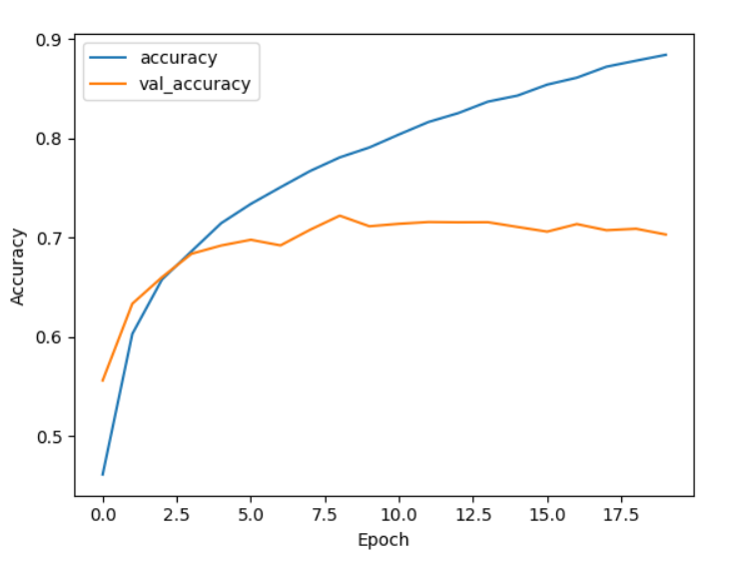

Figure CNN training/validation accuracy

Figure 2 shows the training and validation accuracy of a CNN model over 19 epochs. While the model's training accuracy consistently improves, the validation accuracy plateaus around epoch 10, indicating potential overfitting. The growing gap between training and validation accuracy further supports this conclusion. To address overfitting, techniques like early stopping or regularization could be implemented to improve the model's generalization performance.

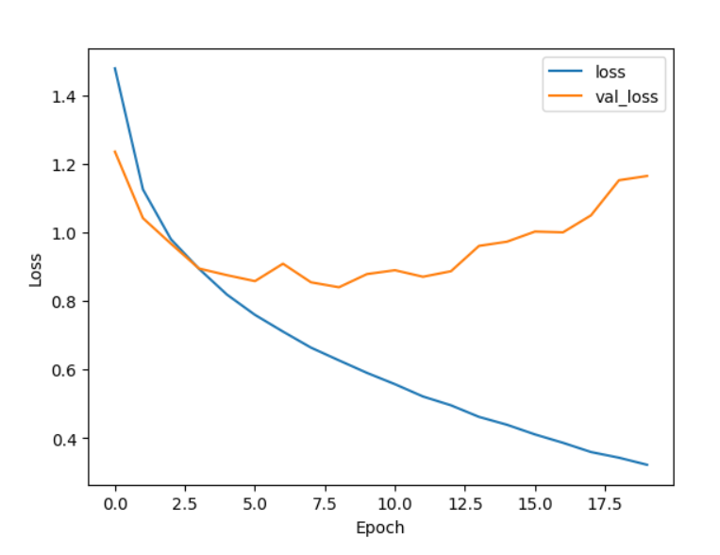

Figure CNN training/validation loss: effective learning

Figure 3 displays the training and validation loss of a CNN model over 19 epochs. Both the training and validation loss decrease steadily, indicating that the model is learning the data effectively. However, the validation loss starts to increase slightly after around epoch 15, suggesting potential overfitting. To improve the model's performance, techniques like early stopping or regularization could be implemented to prevent overfitting and ensure better generalization to unseen data.